Wang Siao Shuen
CT0380177 / 35517767
GRD263 Report
Web Analysis Report

Table of Contents
Introduction 2
Analysis 2
Defining client’s message 2
Building a concise hero section 2
Having a clean and readable design structure 3
Making the website relevant to users 4
Building user trust 5
Enhancing user engagement 6
Simple navigation 6
Strong and repeated CTA buttons 6
Mobile-friendly design 7
Conclusion 7
References 8

Introduction
When it comes to web design, Yocco advises “if you want users to actually pay attention to your message, make it directly relevant and easy to understand.” (Yocco, V., 2014). With this reference, I personally agree with the advice and think that it is important to capture the audience’s attention by designing a website that is direct and matches with their needs. Hence, I designed Aspect’s website by ensuring that the content is directly relevant.

Analysis

Defining client’s message
According to Yocco, a persuasive website ought to convey a single, understandable message to visitors immediately. I made sure the message of # was clear in my design by building a concise hero section and having a clean and readable design structure.

Building a concise hero section
As seen in Fig. 1, I positioned a bold headline and subtitle that clearly convey the brand’s value and proposition at the sides of the webpage. Additionally, the background image used directs the user’s eyes towards the headline and subtitle. This is similar to Yocco’s suggestion that consumers should be able to understand a website’s goal in a matter of seconds without experiencing any cognitive overload.
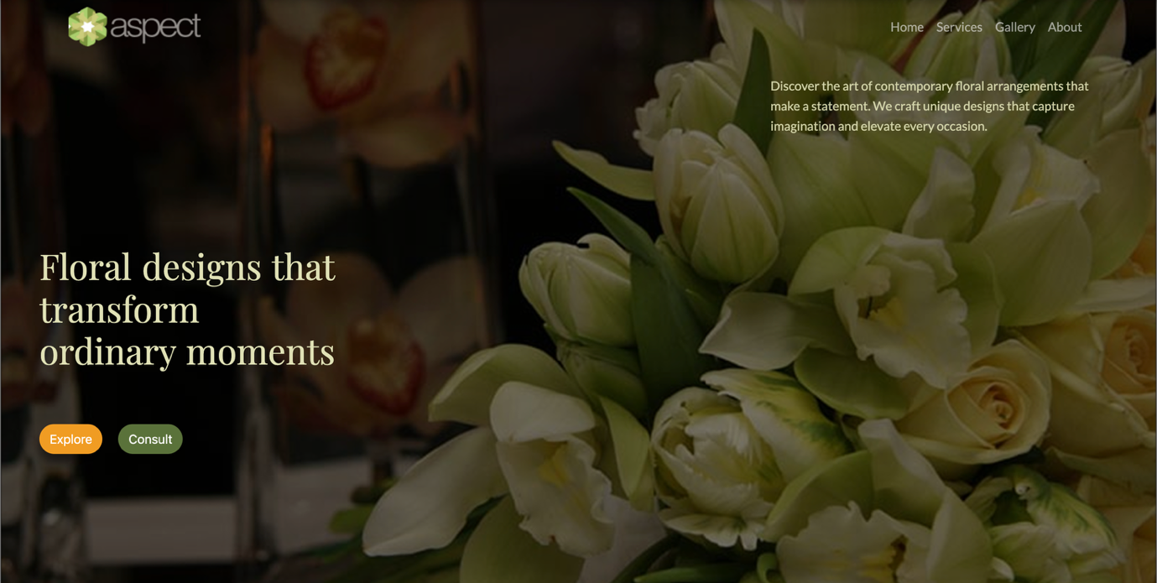
Fig. 1

Having a clean and readable design structure
According to additional research (Bent, A., 2022), the creation of a design’s user flow is a part of information architecture (IA). There are several ways that UX designers integrate IA into their designs. To prevent visitors from becoming sidetracked, elements are presented utilising visual hierarchy such as prominent buttons, a large title, and smaller supporting text, as shown in Fig. 2.
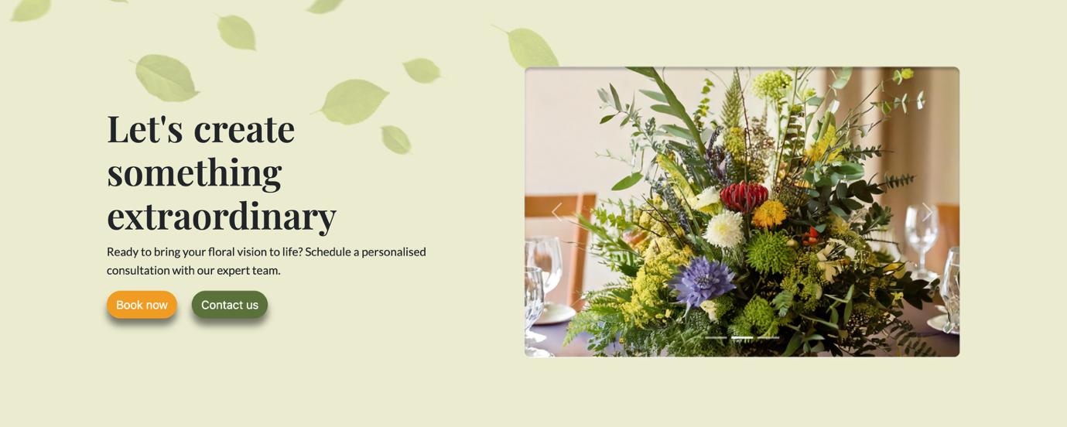
Fig. 2

Making the website relevant to users
Yocco mentioned that in order to create persuasive design, it is necessary to comprehend user motivations and incorporate them into the structure and content. In order to make the webpage relevant, I worked on producing user-focused content, providing quick access with simple words on the navigation bar (refer to Fig. 1) for users to reach information, and adopting a consistent brand personality throughout all pages as shown in Fig. 3, 4, and 5.
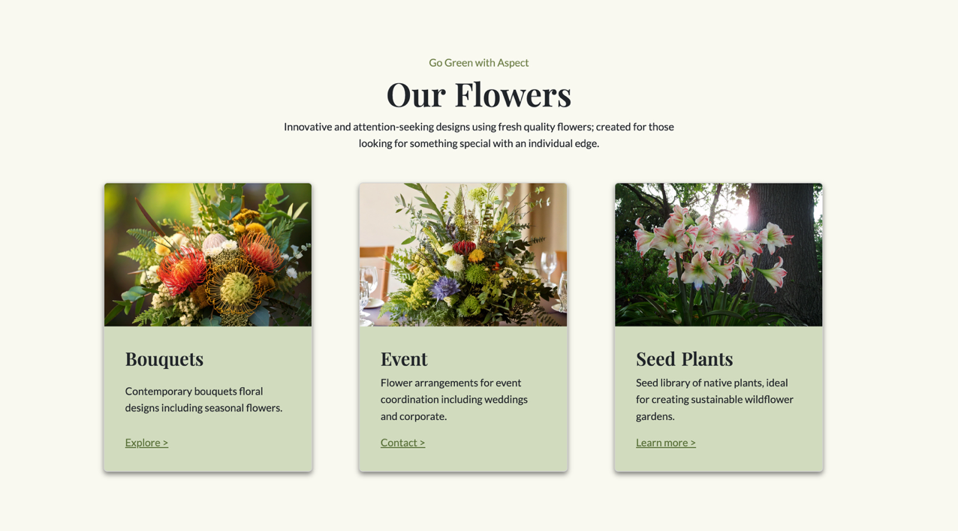
Fig. 3
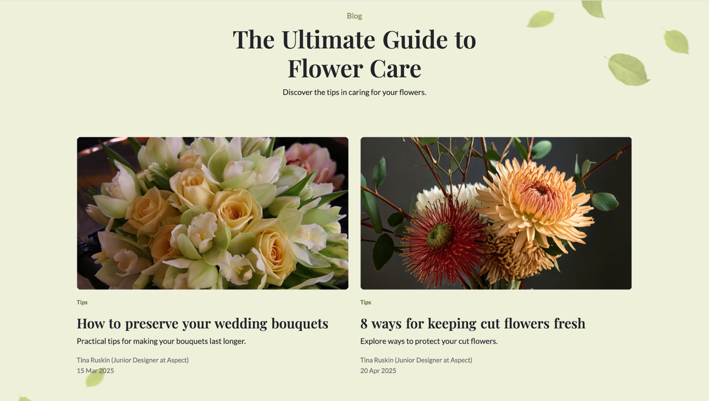
Fig. 4
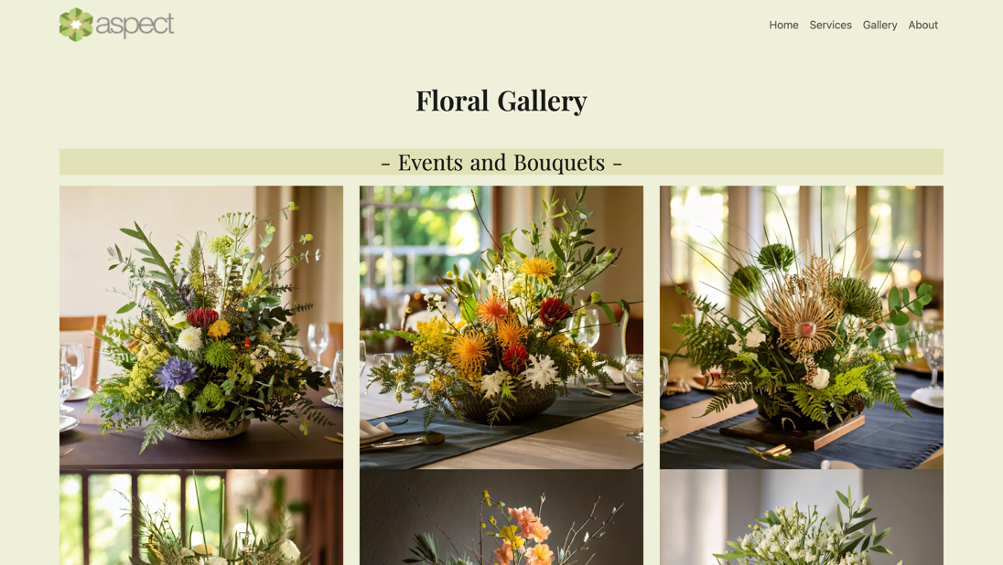
Fig. 5
As shown in the examples, I adopted a bright and clean visual tone with hues of green and classy typography, Playfair and Lato, to match the identity of Aspect. This creates emotional relevance and brand consistency.

Building user trust
According to the client’s request, one of the main UX goals is to help their visitors to gain trust from the brand. I have included an entire section of testimonials and authentic reviews from the previous clients Aspect worked with to increase credibility for the brand (refer to Fig. 6). Keeping Yocco’s advice in mind, I added this section directly after the product offerings to ensure that users can view the testimonials without having to scroll too much.
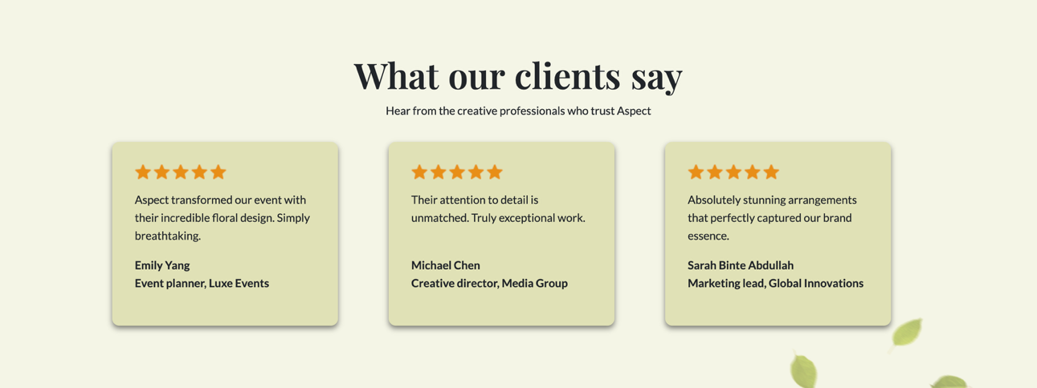
Fig. 6

Enhancing user engagement
According to Yocco, a persuasive website needs to make intended activities clear and easy to do with simple steps. Thus, I put this into my design by introducing simple navigation, strong and repeated Call-To-Action (CTA) buttons, and having a mobile-friendly design.

Simple navigation
As seen in Fig. 7, users can find important information more efficiently with a simplified top navigation bar that includes Home, Services, Gallery, and About. As users jump into any of these pages, they can still access the navigation bar as it is guaranteed in all pages throughout the website.
Fig. 7

Strong and repeated CTA buttons
Referring to Fig. 1 and 2, the locations of buttons like “Explore”, “Consult”, “Book Now”, “Contact Us”, and “Subscribe” are predictable. They minimise decision effort by using clear language and creating a contrast with the background. Furthermore, the final CTA section in Fig. 2 is placed right before the footer to further prompt and encourage users to make a booking with Aspect. The “Subscribe” button at the footer section allows users to stay connected and alerted for any promotions, new blog articles, and new product offerings (refer to Fig. 8). It is also a good way to engage users and offer an exclusive user experience.
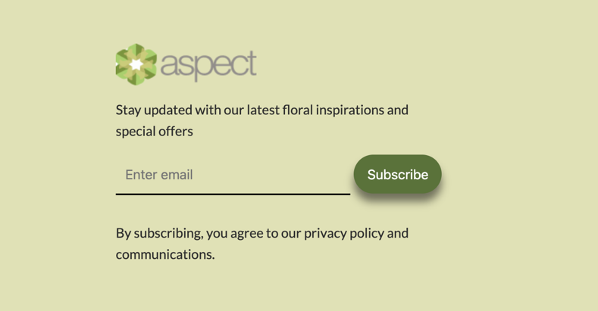
Fig. 8

Mobile-friendly design
A significant aspect of enabling action involves reducing challenges for users on smaller devices such as tablet and mobile versions through the responsible scaling of button sizes, spacing, and font. To ensure that Aspect’s website is user friendly on both tablet and mobile version, I have adjusted some of the font sizes and display specifically for smaller devices as shown in Fig. 9.

Fig. 9

Conclusion
Using the design concept and ideas of Victor Yocco, I was able to create a website that clearly conveys the client’s message and matches the needs of the users with the use of user-focused content which promotes user engagement and ease the browsing process. This report is supported with screenshots of my website design that further articulates how each idea is applied in my design.

References
Bent, A. (2022, July 30). The Importance of IA in UX Design. UX Magazine. https://uxmag.com/articles/the-importance-of-ia-in-ux-design
Yocco, V. (2014 July 1). Persuasion: Applying the Elaboration Likelihood Model to Design. A List Apart. https://alistapart.com/article/persuasion-applying-the-elaboration-likelihood-model-to-design/

